Evaluation and Assessment for Technology

Evaluation Design
Dover Schools is committed to conducting a systemic, rigorous, and highly formative evaluation process that aims to measure the impact that this Strategic Technology Plan is having in schools and classrooms throughout the district. This evaluation goes well beyond accounting for technology infrastructure and reporting quantitative data on students, teachers, and administrators achieving basic technology literacy benchmarks. In addition to such basic data, the district’s technology plan evaluation effort will report on the qualitative impact of technology on teaching and learning. Through such data, and the formative reflection on progress that this will support, Dover Schools will be in a position to monitor the impact of its technology infrastructure, technology policy, and technology professional development initiatives. This will allow for responsive and frequent fine-tuning of efforts; and ultimately a much greater degree of accountability for the use of resources to support instructional technology.

Through this evaluation plan, Dover Schools will apply a uniform data collection process, using a standardized set of evaluation tools that have been specifically mapped to the plan’s goals and objectives. These tools include teacher, student, and parent online survey instruments, classroom observation protocol, and interview/focus group questions for teachers and administrators. Dover Schools will initiate a data collection effort in the spring of each school year that collects data at the classroom level. Information collected in this manner will create a uniform dataset to be used to determine the district’s progress toward meeting the indicators in the technology plan.

Evaluation and Technology Plan Updates: 2016 – 2019
The following table describes the main activities associated with technology plan evaluation and technology plan updating between Fall 2016 and Fall 2019.

Date |  | Activity | Responsibility | Product/Outcome
2016 | Fall  (October/November) | Develop data collection instruments | Admin. Staff | Data collection instruments properly mapped to technology plan indicators and other Dover Schools initiatives as necessary
2017 | Spring  (March/April) | Data Collection – Surveys, Focus Groups, Observations | Admin. Staff
2017 | Late Spring  (May/June) | Data Analysis and Reporting | Admin. Staff  School Staff | Data reports and data review meeting with District and School Staff
2017 | Fall | Technology Plan Update | Admin. Staff  School Staff | Updated District Plan
2018 | Spring  (February) | Data Review (2017 data) | Admin. Staff  School Staff | Updated technology-related goals/actions
2018 | Spring  (March/April) | Data Collection – Surveys, Focus Groups, Observations | Admin Staff
2018 | Late Spring  (May/June) | Data Analysis and Reporting | Admin Staff  School Staff | Data reports and data review meeting with District and School Staff
2018 | Fall | Technology Plan Update | Admin Staff  School Staff | Updated District Plan and Updated School Technology Plans
2019 | Spring  (February) | Data Review (2018 data) with schools | Admin Staff  School Staff | Updated technology-related goals/actions
2019 | Spring  (March/April) | Data Collection – Surveys, Focus Groups, Observations | Admin Staff
2019 | Summer | Data Analysis and Reporting | Admin Staff  School Staff | Data reports and data review meeting with district and school staff
2019 | Fall | Technology Plan Revision | Outside Facilitator or  Admin Staff  School Staff | Revised District Plan (2020 – 2023)

Dover Schools’s Technology Organization

The Dover Schools Public Schools recognizes its responsibility to further the District’s instructional goals through the integration of appropriate, high quality technology with the instructional programs and administrative functions. Key to this effort is the establishment of a strong connection between technology management and delivery of curriculum and instruction. The necessary support for the oversight and management of this initiative will create a strong connection between the technology program and curriculum and instruction.

The Technology Committee
With the implementation of the 2016 – 2019 Strategic Technology Plan, the focus of the District Technology Committee will be aligned with the vision for Instructional Technology as presented in this plan document. The Technology Committee is composed of District stakeholders such as teachers, administrators, School Board members, parents and other community members. This Committee will meet regularly to oversee the broad implementation of the District’s Technology Plan, and will serve to meet the District’s policy and procedures for the proper acquisition of technology. The Committee will provide guidance and input into how the District interprets the technology needs and how these needs are met through the various initiatives, purchases, and actions of the district staff working to support technology as a tool for teaching and learning.

Stakeholder involvement and oversight are critical for gaining the buy-in necessary for technology to be implemented meaningfully throughout the District. Most importantly, by engaging regularly with this plan, the Technology Committee will insure that the plan is more than a “document on the shelf” but instead provide a roadmap that is focused on the needs of all learners and continually assessed as to its ability to meet and support the curriculum requirements. To foster the connection between the technology program and curriculum and instruction, the Technology Committee will include representation from the District’s curriculum and instruction administration.

Technology Management and Staffing
The structure for roles and responsibilities related to technology management and staffing are described in the following brief position descriptions.

Technology Department Management and Staffing

The current Strategic Technology Plan specifies a revised structure for roles and responsibilities related to technology management and staffing. This structure is shown below and described in the following brief position descriptions.

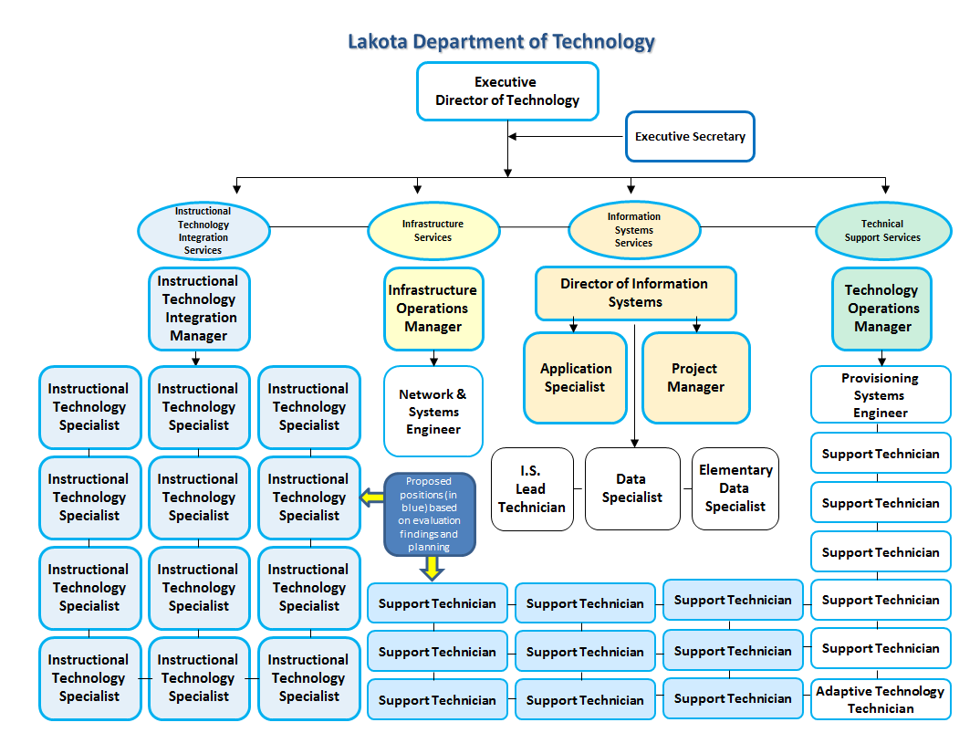

District Technology Coordinator

This position oversees all District Technology operations, while collaborating with all areas of the district to provide technology solutions for instruction and operations. This person is also responsible for the department budget, vendor contract negotiations, project and staff management, district technology policy, industry trends assessment, planning, resource allocation and efficiency improvements. The Director ensures that federal, state and district policies, such as CIPA, eRate technology needs, NH State Department of Education technology requirements are supported and completed.

Instructional Technology Integration Services

Instructional Technology Integration Manager (Proposed)

This position – to be hired in 2013 (see District Policy, Goal 2) - researches, plans, coordinates, and oversees the implementation of district instructional technology initiatives for all schools K-12. This includes staff professional development, instructional technology solutions management, vendor coordination, intra district and community collaboration and communication, and ongoing staff and school support. This position oversees all instructional technology specialists.

Building-Based Instructional Technology Specialists (12 Proposed)

These positions – to be hired in 2013 (see District Policy, Goal 2) - work directly with building leaders and staff to integrate District instructional technology initiatives. This work includes the development of ongoing face to face and on demand staff professional development, the setup and management of ongoing central instructional technology solutions, as well as the evaluation and required modification of these initiatives to meet District instructional technology goals and timelines. This team will report to the Instructional Technology Integration Manager and will utilize the ISTE NETS-C standards for instructional technology coaching.

Infrastructure Services

Infrastructure Operations Manager (Previously Network Administrator)

This position manages the entire district network, including connectivity between all buildings. This includes roughly 250 managed network routers; 15,000+ network drops; 450+ wireless network access points; access controls; network and web security; specialized networks for phones, cafeterias, and data center; guest and Internet-only access; all data/server backup services and disaster recovery; power backup systems for all core network devices and data centers. This person serves as the Lead Administrator for the Infrastructure Services Team.

Network and Systems Engineer

This position manages, supports and monitors all infrastructure data center and central District systems, including servers, applications, and power management. In addition, this person, oversees core enterprise solutions, system policy management, and thin client operations and assists with tier one network support services.

Information Systems Services

Director of Information Systems

This position oversees the student data systems, including all administrative functions, teachers’ grade books, the student/parent portal, and dozens of interfaces to peripheral databases and outside entities. This position is responsible for overseeing the Special Services’ software system and maintaining district-wide content management sites. The Director coordinates data solutions for a variety of district instructional and operational departments as well as government agencies. The Director oversees Information Systems’ budget development and management, and is responsible for vendor relations, professional development offerings, project management, communications, and collaboration with district, regional, and state constituents to ensure mandates and needs are met efficiently and effectively. This person serves as the Lead Administrator for the Information Systems Team.

Project Manager (Butler County Employee)

The Project Manager position is responsible for the discipline, medical, success plan, RTI, assessment, ELS, 504 and gifted student data management. This position also performs database management and security duties as well as verifies access to the Student Information System. In addition, they maintain the Cognos student catalogs, write district student information reports and oversee new software module implementations.

Applications Specialist (Butler County Employee)

The Applications Specialist position is responsible for maintaining the master schedule, student schedules, the teacher grade book, transcripts, report cards, interim reporting, graduation requirements, course requests, athletic eligibility, and attendance setups at the district level. This position performs continual data analysis to address issues preemptively, writes reports and resolves Help Desk issues to support the buildings, the Teaching and Learning Department, and EMIS.

Information Systems Data Specialist

The Information Systems Data Specialist position is responsible for performing operational duties for the Information Systems Services team. This position writes and maintains district reports and performs data audits. The position also provides Tier one student information system direct support to office and classroom staff , sets-up and maintains teacher accounts for the district’s Student Information System and provides onsite training.

Elementary Data Specialist

The Elementary Data Specialist is responsible for supporting elementary buildings in maintaining their student data and assisting with data entry. This position provides assistance with elementary report cards, interim reports, master schedules, and student schedules. This position provides guidance in registration procedures, verifies community school enrollments and SSID continuity, supports the Enrollment Center, and performs data analysis to ensure data integrity. This role allowed for a consolidation of building duties, resulting in District savings.

Information Systems Lead Tech

The Information Systems Lead Tech oversees all central Special Services data system applications. This position provides professional development for users and researches ODE updates and changes regarding Special Education practice and procedures. The Lead Tech works with the EMIS Coordinator as a quality check for compliance and coordinates required student records transitions.

Technical Support Services

Technology Operations Manager (Previously User Support Supervisor) (Half Funded by Child Nutrition)

This position provides technology project management, day-to-day technology operations, and customer service for District classroom, administrative, assistive, and child nutrition technologies. This includes the management of purchased services, staffing and technical support resources as well as hardware procurement, end station security, software management and asset management.

Provisioning and Systems Engineer

This position manages over 10,000 technology accounts and access and provisioning for all staff, students, and contractors in order to support both instructional and operational technology needs and to ensure compliance with district, state, and federal regulations imposed by district administration. This person also manages all print services, user access support, internet filtering access and imaging services while managing all related central systems.

Adaptive Technology Technician

This position manages all Student Services Assistive technology needs district-wide. This includes IEP technology compliance, classroom solutions, specialty software, systems, etc. Works with IEP teams to develop appropriate and efficient technology solutions for students with assistive technology needs.

System Support Technicians (6 Current, 9 additional proposed)

The six current positions are district technology field technicians that personally address all staff, student, and administration technology service requests for all 6000+ computers, 500+ printers, and multiple software packages at all 26 district buildings. Each technician is assigned to four to five buildings. They are responsible for successfully closing over 9,000 tickets annually.

The November 2012 technology program review recommended increasing the number of technology support staff by nine employees. Until additional positions are added, we recommend reinstating the Building Technology Representative each school building. These positions previously had received a small stipend to provide technology support in their building.

Additional Network Support (Purchased Services)

Due to the exponential expansion of the District’s network, the need for additional management, security and support are increasing dramatically. This will be addressed with an increase in purchased services support to supplement our one network administrator in supporting the District’s network management, allowing the network administrator to focus on, infrastructure services management, improvements and efficiencies.

Dover Schools’s Plan for Technology Infrastructure

Current Configuration (Fall 2016)
In general, technology tools and devices are available in all classrooms. Every classroom has ….. Internet access and is outfitted with a SmartBoard and ceiling mounted projector. Each classroom has two, three or four desktop computers and a teacher laptop. The Library Media Center (LMC) houses a computer lab with 24 desktops and a color printer. The Middle School utilizes a laptop cart outfitted with 24 laptops purchased in the summer of 2013. Eight teachers are currently piloting the use of iPads for classroom instruction.

Wireless access has been managed through individual wireless access points strategically located throughout the school building. Certain areas of the school do not have access to wireless capabilities. During the summer of 2013, the District began a phased infrastructure upgrade completing the first phase of the gradual conversion to a centrally managed wireless access system, replacing the three existing network servers with three virtual servers, and converting from Novel to a Windows operating system.

Anticipated Expansion and Upgrades

Computing Devices

Student:
By the 2014-2015 school year, over 80% of our computer fleet will be 7-9 years old. To ensure the reliability of the instructional technology tools available for learning and testing, replacement computing devices are required. While our state does not currently provide a recommended ratio of student to device, Louisiana, another state in the same device-based assessment consortium (PARCC), recommends a 7:1 minimal ratio for the tests, as well as a 5:1 – 1:1 ratio for learning. Therefore, we are recommending a 5:1 target ratio for Dover Schools Schools.

Device specifications from the Technology Readiness Program referenced above, along with instructional goals, grade-based BYOT requirements, expansion, possible student technology fees and funding will be monitored closely as this will affect Dover Schools’s realistic ratio as well as the devices ultimately recommended.

Teachers:
In order implement the various instructional activities described in this Strategic Technology Plan, all Dover Schools teachers will require a mobile computing device to create instructional content, participate in on demand and online professional learning, collaborate with staff, facilitate instruction and model instructional technology best practice with their students. The District will therefore need to supply a core device that will allow teachers to create curricular content, access high-bandwidth network resources (e.g., Web 2.0 resources), interface with existing technology devices (e.g., 3M boards), and effectively communicate with various online systems and networks (e.g., cloud-based collaborative environments, and online learning systems). Staff are encouraged to supplement their district supplied device with grant funded or self-funded complimentary peripherals that further promote the initiatives of this plan at the classroom level.

Device Management
Existing and replacement computing devices will require up-to-date device management tools that allow for management, maintenance and ensure efficient operations and security. Dover Schools will be pursuing such a device management solution.

Network Infrastructure

Dover Schools’s network infrastructure must provide a comprehensive, interconnected, foundation for learning and operations. As such, the district’s physical and wireless network infrastructure will be upgraded to support the capacity necessary to meet our instructional and information management needs.

Web 2.0 and learning resources aligned with instruction goals should be accessible, while ensuring filtering regulations and student safety. Therefore, the district will aggressively upgrade its network bandwidth over the next three years to meet state and national guidelines for educational networks. Furthermore, state online/PARCC assessments require a stable, secure and accessible network foundation. This requires the retirement of legacy network hardware still in place. The district will also need to upgrade its network filters so as to enable expanded security and more flexible accessibility for learning.

As the district continues to evaluate and assess new initiatives, the network infrastructure must be constantly evaluated and funded to ensure long term performance of instructional technology.

Data Center
Five years ago, the district initiated a virtualization project intended to streamline management, energy, space and hardware costs. At this time, the initiative requires refreshed capabilities and expansion to further expand long term savings. In addition, the district will also replace core data center systems – such as the power backup system, core hardware, and monitoring solutions – which are currently at the end of their life cycle.

Cloud
While virtualization improves efficiency of data center operations, certain cloud solutions can provide improved return on investment and total cost of ownership for district technology offering. The total cost of ownership of cloud-based solutions will be evaluated as part of every new purchase this plan calls for to ensure project goals are met with the most efficient and cost effective solution.

Printing
Dover Schools will continue to investigate ways that District Printing Services can be further streamlined with managed services and electronic solutions as alternatives to paper-based printing. Printing devices should be consolidated based on instructional and operational needs, as the District’s reliance on paper further decrease as a result of these initiatives.

Communication, Productivity and Collaboration Systems:
With communication central to district operations, reliance on electronic messaging increases daily. In addition, mobile access to resources and systems for collaboration and productivity are essential to meeting the district’s vision for instructional technology.

The district will employ cloud-based cross-platform solutions – many available at little or no cost to the district – to enable staff to access full messaging and groupware functions from district devices as well as personal mobile devices. These solutions will integrate productivity tools as well as collaboration. Likewise, the district will explore an internal social networking solution to allow staff to work collaboratively across buildings to engage in professional learning, curriculum development and student centered discussions.

Student groups will also be provided cloud-based productivity tools that allow for collaboration and electronic assignment management, resulting in a savings of time and the cost of paper and printing. It is noted that implementation of these new tools for students will require individual accounts for students.

The district will implement technology-based assessment solutions that allow our staff to assess student progress and provide instructional staff access to data and reports. Efficient access to assessment data is critical in terms of allowing teachers to differentiate instruction and thereby meet the needs of all learners.

Classroom Technology

As existing devices such as interactive whiteboards, document cameras, student response systems etc., begin to age and approach end of life, new solutions are required when these devices fail and cannot be repaired or the cost of the repair is comparable to the value a new device. The district will support and replace these devices to ensure learning environments are complete.

The district will explore the implementation of a cloud-based learning management system that allows for digital content collaboration, parent portal, blended and full online course development, professional learning, curriculum sharing and several more features aligned with the initiatives of this plan. Dover Schools will determine all instructional needs and consider a district-lead, consortium-lead, or state-lead solution. As this plan was being finalized, state officially announced plans for an Instructional Improvement System. Features of this new Instructional Improvement System include:

- Online access to curriculum and standards
- Curriculum customization
- Easy to use paper, online and clicker test administration options that teachers can use to determine what progress students have made and what help they need
- Data analysis and reporting capabilities as well as a portfolio of every students’ work

Blended learning options to supplement face to face instruction are also slated to be part of the package. The state will incorporate iLearnstate.org, a one-stop home for high quality K-12 content that is aligned with the state’s new learning standards. This will not be available to Dover Schools until after all participating districts that are part of the Federal Race to the Top program have been integrated, projected to be by the spring of 2014.

Online Courses

Dover Schools will continue to evaluate possible solutions for additional online course offerings that will meet the initiatives of this plan. The district’s infrastructure will provide the required access for students to continue to participate in current online courses as well as grow to meet the technical needs of future offerings.

Purchasing

All district technology purchases should be submitted to and reviewed by the Executive Director of Technology, regardless of funding source.

All approved hardware and software will be standardized and advertised to all buildings.

Replacement Plan
Finally, we note that while the creation of this strategic technology plan takes place at a time when the district needs to invest in several infrastructure upgrades, including completely new student and teacher computing devices (due to the advanced age of the existing workstations as of Spring 2013), it is essential that future technology plans take into account the need for a hardware replacement cycle focused on meeting the instructional technology vision. By partnering with the community on a permanent improvement levy, the district could fund a consistent annual infrastructure improvement program, with 20% of the annual hardware purchasing budget allocation to future replacements. Such a funding arrangement would allow for payment opportunities such as leasing and allow for larger investments to be spread over multiple years. This would also allow for long range financial planning, thereby preventing technology deficits and instability in the district’s instructional technology program.

Funding

This multi-year living plan will be implemented from July 2016 through June 2019. It is Dover Schools’s intent to begin the implementation of the goals and actions of this Strategic Technology Plan as soon as possible, in service of the district’s mission and overall vision of the plan. Given that several of the action items identified in the plan require funding, the implementation of these items will be contingent on available funds. The district plans to utilize the following funding sources in order to support implementation of these action items: Allocation of funds within the operating budget, grants and private funding, and establishment of community partnerships. These funding strategies are discussed in more detail below

Allocating funds within our Operating Budget

Each year funds will be requested through the annual budget process. The amount requested will vary based on the aggressiveness determined to implement the action items in a timely manner. The 2016-2017 School Budget includes $X for the purpose of replacing aging computers. This amount is based on replacing aging administrative and instructional desktops and other technology equipment (e.g. SmartBoard projectors) that have far exceeded their warranty periods.

Grants and Private Funding

Efforts to identify grants and private funding are in process, not only for technology but for other areas of need as well. Any funds received for this purpose will allow the District to accelerate implementation based on priorities unless there is a specific funding requirement that establishes a use of the funds that is not consistent with the priorities established in this plan. The speed of implementation will be based on opportunities and specific funding request requirements.

Establish community partnerships

The District's Technology Committee will research and reach out to other community resources and establish partnerships. A focus will be on matching action items to community expertise and determine if the community has the resources to assist with the implementation of identified action items.

